**Ideation Phase**

**Define the Problem Statements**

|  |  |
| --- | --- |
| Date | 23-JUNE 2025 |
| Team ID | LTVIP2025TMID55096 |
| Project Name | Docspot |
| Maximum Marks | 2 Marks |

**Customer Problem Statement Template:**

To define the core problems freelancers face while searching for jobs online, and use those insights to guide the development of Freelance Finder.

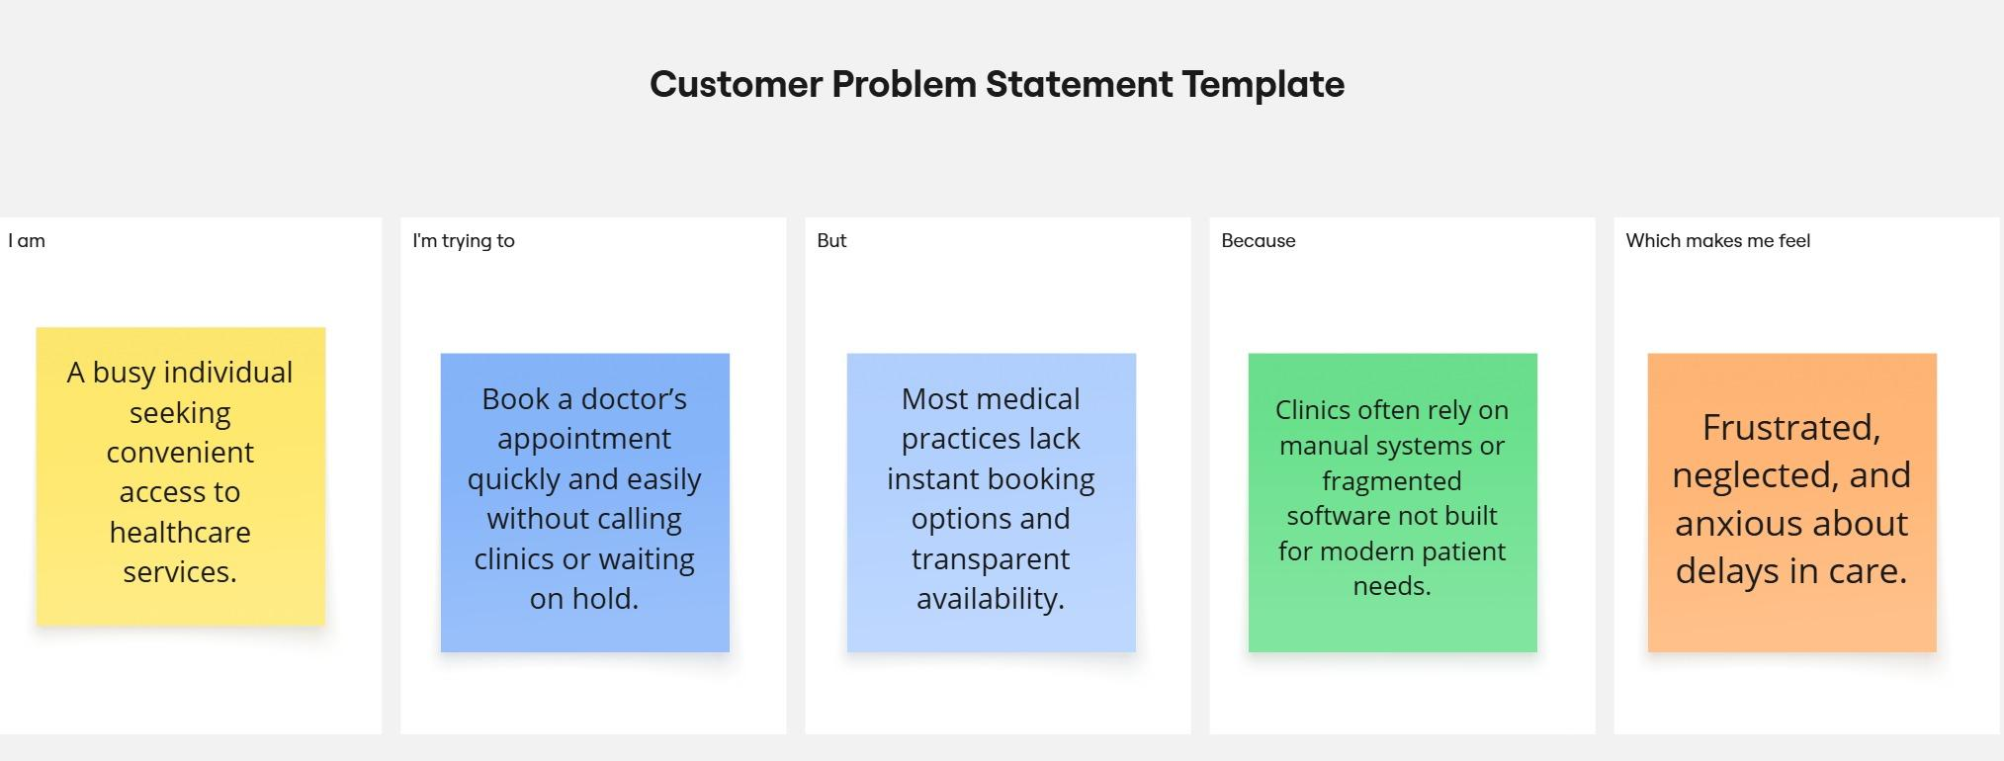

Reference: <https://miro.com/templates/customer-problem-statement/>

|  |  |  |  |  |  |
| --- | --- | --- | --- | --- | --- |
| **Problem Statement (PS)** | **I am (Customer)** | **I’m trying to** | **But** | **Because** | **Which makes me feel** |
| PS-1 | a working professional with a tight schedule | book a doctor’s appointment quickly without phone calls or long wait times. | most clinics don’t have real-time booking systems or clear availability info | their systems are outdated or fragmented | frustrated and anxious about my health getting worse while waiting. |
| PS-2 | a general physician running a small clinic. | manage patient bookings efficiently and reduce no-shows. | my current tools are manual or not tailored to healthcare workflows. | I can’t afford or understand complex clinic management systems. | stressed and underpaid despite my busy schedule. |